**Instructions for use**

My project needs to run via Python and use the miniconda3 environment.

**Project Overview**

This project is a natural language processing project which aims to implement the generation of poems through RNN algorithms, the main functions include cleaning up the text, generating vocabulary lists, building indexes, building RNN models, setting up model parameters and so on.

**Dataset**

The dataset used in this project is from the dataset of poetryfoundation website

**Results.**

We may not be able to generate fluent poems directly, but only as a creative aid.

Here are two screenshots of the results

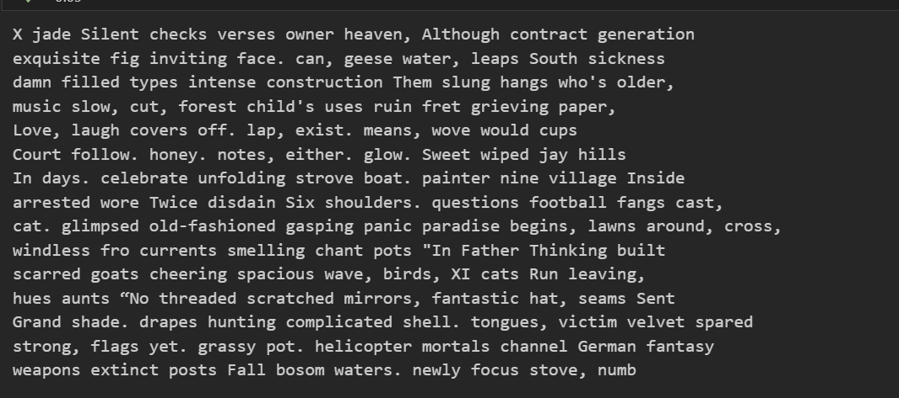

**Notes**

For clean text I refer to

https://pypi.org/project/clean-text/

RNN reference code site

https://git.arts.ac.uk/tbroad/NLP-23-24